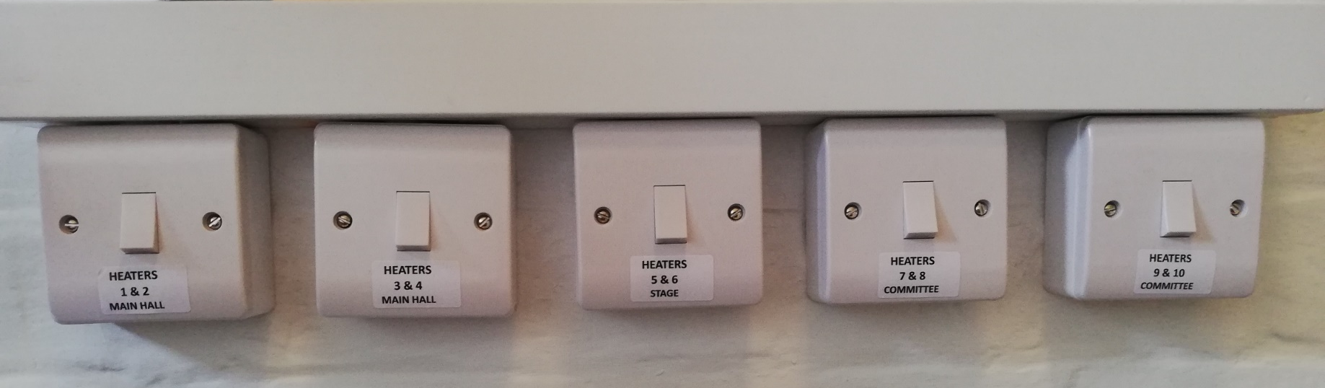
Infrared Heating Controls – situated in the rear hallway
Please ensure all heaters are switched off before leaving the premises. Thank you.
Committee Room by windows

Committee Room
by entrance door

Stage

Front Main Hall by entrance door

Rear Main Hall by exit door

