Onneley Village Hall
  - Newsletter: January 2023
Highlights 2022

Platinum Jubilee ‘bring your own picnic’ success
Afternoon Tea and Quiz Night raised £1100 for Ukraine Appeal
Charity & Craft Fair, £81 given to each of 5 charities
Christmas Meal enjoyed by 40 local villagers
Carol Singing round the village raised £200
FUTURE EVENTS 2023
Valentine Afternoon Tea 19 Feb
King’s Coronation 7/8 May
Village Walk TBC
Charity & Craft Fair November
Look out for details

A very happy New Year to YOU all!
The Management Committee are pleased to announce their priority for this year is to organise a refurbishment of the hall, including new kitchen and toilet facilities, together with a complete redecoration throughout. We hope to provide an updated venue with improved amenities for community events and individual hirings.
Find us at www.onneleyvillagehall.co.uk

Want to organise an event at the hall?
Members of the Management Committee will be more than happy to help with your arrangements. If the event is for the local community, remember there is no charge for the hire of the Hall.

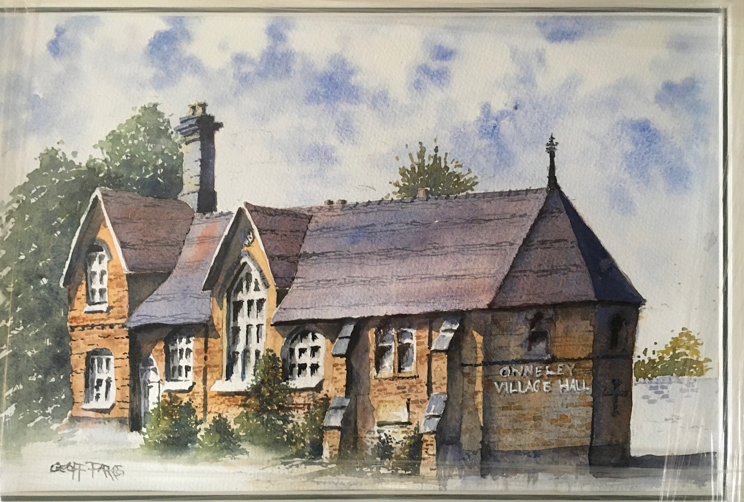
RETIREMENT FROM OFFICE
Jim Barnes stepped down as Chairman in May 2022. As a thank you for his many years of service, an original painting by Geoff Parkes, a local artist, was presented to him at the Quiz Night in November 2022.

FLAG Flying AT half mast
It is with great sadness that the Committee learnt of the death of Mike Craghill on 27 December 2022. As a sign of respect to the former Treasurer of Onneley Village Hall, the flag was raised at half mast. The Management Committee would like to record their gratitude for his decades of service to the village hall and to the local community. Our thoughts are with Abbie and the family at this difficult time.

Water Leak
Before Christmas the Village Hall had a significant water leak. This meant bookings to hire the Hall over Christmas and New Year had to be cancelled. The Management Committee would like to express their regret at the late notice and for any inconvenience caused.
The water leak has now been successfully repaired with a complete new section of water pipe. This means the Village Hall is now available to hire until the refurbishment of the building begins later in the year, subject to plans and grant approval.
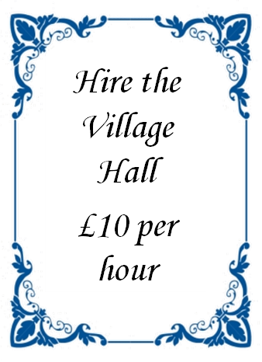

Hire the hall
A competitive £10 per hour for the sole use of the Hall is now available. Ideal for community activities, meetings, parties and/or functions, Contact Louise Alldritt, the booking secretary for details.
Email: louisealldritt1@gmail.com
Alternatively fill in the contact form on the website and the information can be forwarded to the booking secretary.


Keep in touch
Join us on Facebook at the ‘Onneley Village Group’. We currently have 144 members. Share news, views, updates, lost and found and photos. This group is not for personal advertisements or to sell goods.

Your village hall Management committee
Chair: Bernard Finnemore
Secretary: Linda Hopkins
Treasurer: Roger Trippett,
Booking Secretary: Louise Aldritt
Graham Musto, Pam Musto, Tim Baines, Carolyn Finnemore

Onnneley Village Hall Registered Charity: 1058166

