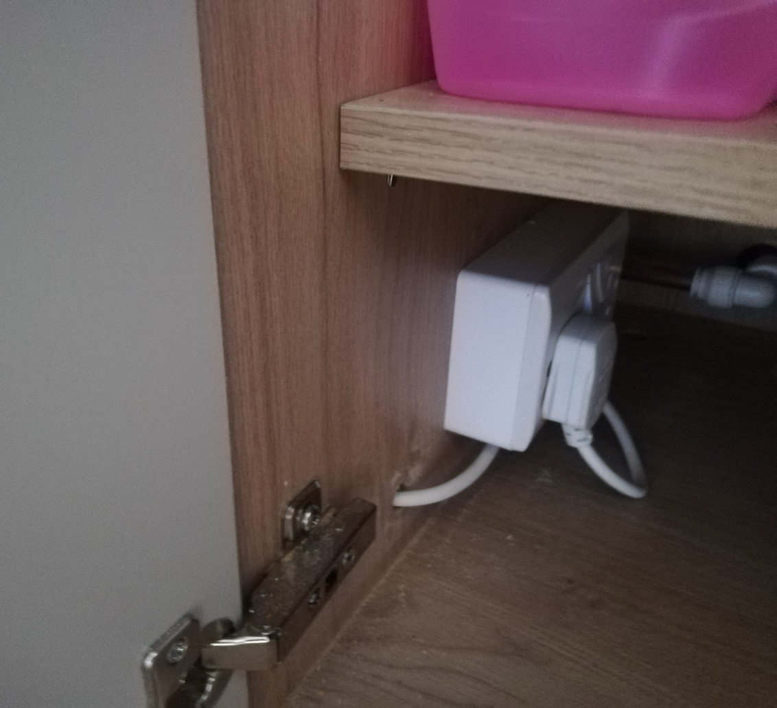
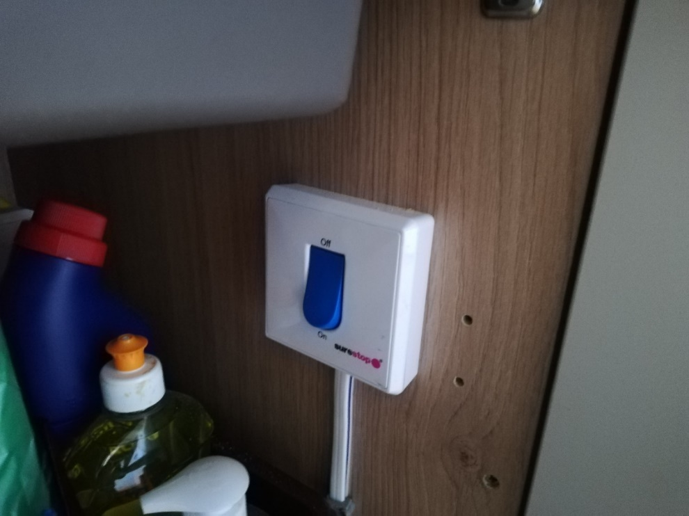
Water and water heating controls
Water heater on/off switch
Water on/off switch
The water on/off switch and water heater on/off switch can be found under the sink in the kitchen.
Please make sure these are switched off when you leave the hall. Thank you

