Onneley Village Hall
  - Newsletter: August 2025
EVENTs Sept - Dec
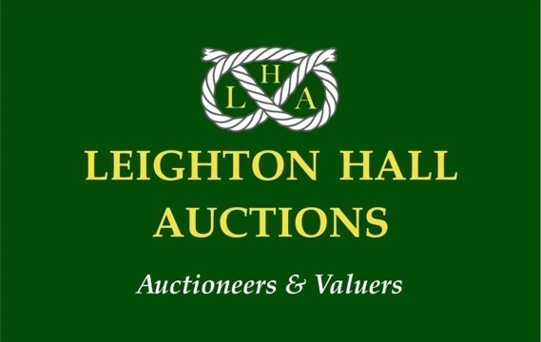
FREE VALUATION DAY
Monday 1 September 2025

Saturday 25 October 2025
Pumpkin Workshop
Saturday 29 November 2025
Christmas Wreath Making
Sunday 30 November 2025
Christmas Wreath Making
Saturday 15 November 2025
Annual Craft & Charity Fair

Friday 5 December 2025
Follow us on Facebook or visit the website!

future events at onneley
The Onneley Village Hall Committee are pleased to announce a number of forthcoming events leading up to the festive season. We do hope you will support these events and help to ensure that we can keep the hall running for the local community.
Find us at www.onneleyvillagehall.co.uk

free ANTIQUES valuation day!
Leighton Hall Auctions Ltd y will be holding a Valuation Day at Onneley Village Hall, on Monday 1 September 2025 between 10am and 12pm.
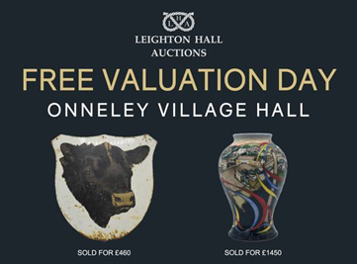
They will be offering complimentary valuations on antiques, pottery, gold, silver, coins, jewellery, militaria and much more!
For more information, please see www.leightonhallauctions.com

Pumpkin & Christmas wreath workshops
Come and join our local florist, Anya, at Onneley Village Hall for a Pumpkin or Christmas Wreath Making Workshop.
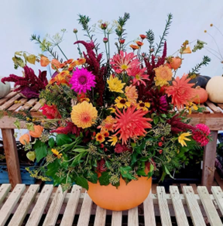
Pumpkin Workshop – Saturday 25 October 2025, 10am –12.30pm

Price per person £58 and includes a drink and homemade cake on arrival and homemade soup and a cheese scone for lunch.

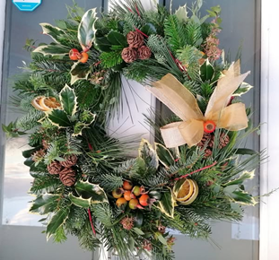
Christmas Wreath Making Workshop – 4 workshops available.
Saturday 29 November 2025, 10am till 12.30pm, and 1.30pm till 4pm
Sunday 30 November 2025, 10am till 12.30pm, and 1.30pm till 4pm
Each workshop is £58 per person and includes a drink, mince pie, homemade soup and cheese scone. All materials included and full guidance given.
Early booking is essential to avoid disappointment, so message Anya soon to book your place.

Charity & craft fair
Our annual event will take place on Saturday 15 November 2025 from 11am till 3pm. Various craft stalls will be in attendance, together with local charity groups. We have availability for a few more local crafters; if you know anyone who might be interested to join us, please ask them to contact via the website. Tables are £10 for the session.

Christmas meal
A big thank you to Chris Hopkin who had kindly agreed to manage this function and has secured outside caterers, fresh2u, who come highly recommended. The meal will take place on Friday 5 December 2025. If you have not received any details about this event, or need to book your place, please contact chris.hopkin77@gmail.com From 30th September, any remaining places will be offered to friends and family beyond Onneley.


hire the hall
Hire the Hall. Charges available on request.
The hall now has regular bookings for Leighton Hall Auctions Ltd and is the venue for floral workshops by Anya. The hall would be suitable for many arts/craft classes, wellness activities, or for meetings, seminars, talks, etc. Children’s parties will be considered subject to age, number attending and proposed activity.
If you think the hall would be suitable for your event/activity, please contact Linda Hopkins for further details, email: linda.graceland@outlook.com

THE Management committee NEEDS NEW members
Are you interested in what happens to the Village Hall? We need new members to help with the running and maintenance of the Hall. Without a group of trustees, we will be forced to give the Hall back to the church. Can you spare a little time and effort to keep the Hall up and running for the community? We’d love to hear from you.

Your village hall Management committee
Chair: Bernard Finnemore, Secretary: Pam Musto, Treasurer: Linda Hopkins Graham Musto, Tim Baines, Carolyn Finnemore.

Onnneley Village Hall Registered Charity: 1058166

